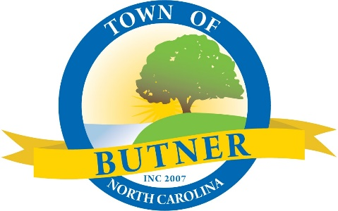
Town Manager's Report
January 4, 2024

Gazebo Park – Signs, Performance Stage and Landscaping – We have received complaints regarding large signs and banners posted at Gazebo Park. As a result, we are evaluating our internal policies and reminding the public they must contact the Town for permission and ensure signs meet land development ordinance requirements prior to posting. Also, we have reviewed the performance stage construction timeline and would not be able to have it completed in time for the Butner Summer Festival. Unless the Council feels different, we plan to go through bidding and finalizing contracts in the spring to be prepared with a contractor to begin construction following the festival. Lastly, as a part of the performance stage project there are landscaping requirements that must be met. Some of the existing landscaping has reached its end of life and will need replaced and the large tree on the back of the former flower shop lot will need removed. The council has previously discussed the deteriorating condition of this tree. We intend to bring and review the landscaping plan at your February meeting and seek approval for the tree removal at that time. For Your Information.

Strategic Planning – A strategic planning session for the Council has been scheduled for January 30th from 9am – 4pm with consultant Rick Rocchetti. Rick has previously worked with the Town on strategic planning. The session will provide the opportunity to review and establish the mission, vision, and values for the Town. Rick will be sending pre-work to Council members directly and staff will provide a draft list of current projects, short term, and long-term goals to assist with your thinking. For Your Information.

Salary and Classification Study – The Town is working with the MAPS Group for a comprehensive classification, pay and personnel policy study. We anticipate the study being complete this month and plan for the consultant to present the results at the Council’s Strategic Planning Retreat on January 30th. Salary and classification studies ensure job descriptions are up to date and positions are in proper grades and compensated in line with the market. Implementation of the study will have a significant cost, but is essential in keeping up with the market. The implementation cost could be over $300,000 which would be equivalent to four to five cents on the tax rate. Staff will receive and refine the cost impact during the month of January and work to develop implementation strategies and timelines for Council consideration. For Your Information.

