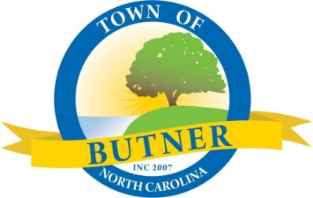
Planning Board Agenda
Thursday, November 9, 2023, 6:30 PM
Town Council Chambers

- CALL TO ORDER

- ROLL CALL

- ADJUSTMENTS TO AND/OR APPROVAL OF AUGUST 10, 2023, MINUTES

- PUBLIC COMMENTS

- CONSIDERATION OF AMENDMENT TO RULES OF PROCEDURE
Town staff have found inconsistencies within the Town of Butner Planning Board Rules of Procedure and would like to propose amending these rules to keep them consistent with the Town of Butner Land Development Ordinance.

- CONSIDERATION OF TA-23-06 WATERSHED REGULATIONS
The North Carolina Division of Water Quality (DWQ) has updated their model
ordinance for the Water Supply Watershed. This proposed amendment is to bring
our ordinance in compliance with these changes. The proposed amendment adds
definitions to article 17 relating to the watershed and simplifies elements of article
15 of the LDO. This is a continuation of the report and discussion at the August 10, 2023 Planning Board meeting.

- CONSIDERATION OF TA-23-08
Town staff requests an amendment to the Land Development Ordinance Sections 7.5.3(H) and 7.5.2 to amend restrictions on food trucks and to allow them to operate outside of Town-sponsored events. This is a continuation of the report and discussion at the August 10, 2023 Planning Board meeting.

- PLANNING REPORT

- BOARD COMMENTS RELATED TO PLANNING BOARD

- ADJOURNMENT

