PUBLIC MEETING DATE: December 14, 2023
EXISTING ZONING: Rural Residential (RR) & Suburban Residential (RS)
REQUESTED ZONING: Planned Unit Development (PUD)
TOTAL ZONING AREA: +/- 334 Acres
APPLICANT: Meritage Homes/ESP Associates
WRITTEN BY: Katie Rhyne, CZO Planner

SUMMARY: The applicant requests rezoning approximately 334 acres off West Lyon Station Road, specifically identified by Map #’s 088803312100, 088701490503, & 088701372426 from Rural Residential (RR) and Suburban Residential (RS) to Planned Unit Development (PUD).
The Planned Unit Development District (PUD) is a special purpose Conditional Zoning District that is established to accommodate a diverse mix of residential and nonresidential uses and structures that function as a cohesive, integrated, and unified development. This district encourages innovative development patterns by allowing flexibility in permitted uses, design, and layout requirements in conjunction with a concept plan. This district may only be established through the process set forth in Article 3.2.3 Conditional Zoning District Classification.
PUD projects are required to submit a concept plan which is to be reviewed by the Planning Board who makes a recommendation to Town Council. Town Council will either approve, approve with conditions, or deny the application. If approved, the PUD may move forward with a preliminary plat.
Originally submitted in May 2023, only minor changes were made to the Meritage Homes project since agenda packets were sent prior to the May meeting. The location of the entrance across from Otho Mangum Road has been designed to have better alignment with the existing road.

Zoning: These properties are currently zoned Rural Residential (RR) and Suburban Residential (RS). Single- Family homes are a permitted use by right in both of these zoning districts, and manufactured homes on a single lot is a permitted use by right in the Rural Residential (RR) zoning district. The minimum lot size is 40,000 square feet with a minimum lot width of 120 feet for Rural Residential, and 15,000 square feet with a minimum lot width of 100 feet for Suburban Residential.

If this subdivision were proposed under the existing zoning districts the amount of homes allowed would be as follows:

RR (for 264 acres): 287 homes
RS (for 70 acres): 203 homes
Total with existing zoning: 490 homes

If the subject property were completely rezoned for either of the existing zoning districts the amount of homes allowed would be as follows:

RR: 363 homes
RS: 969 homes

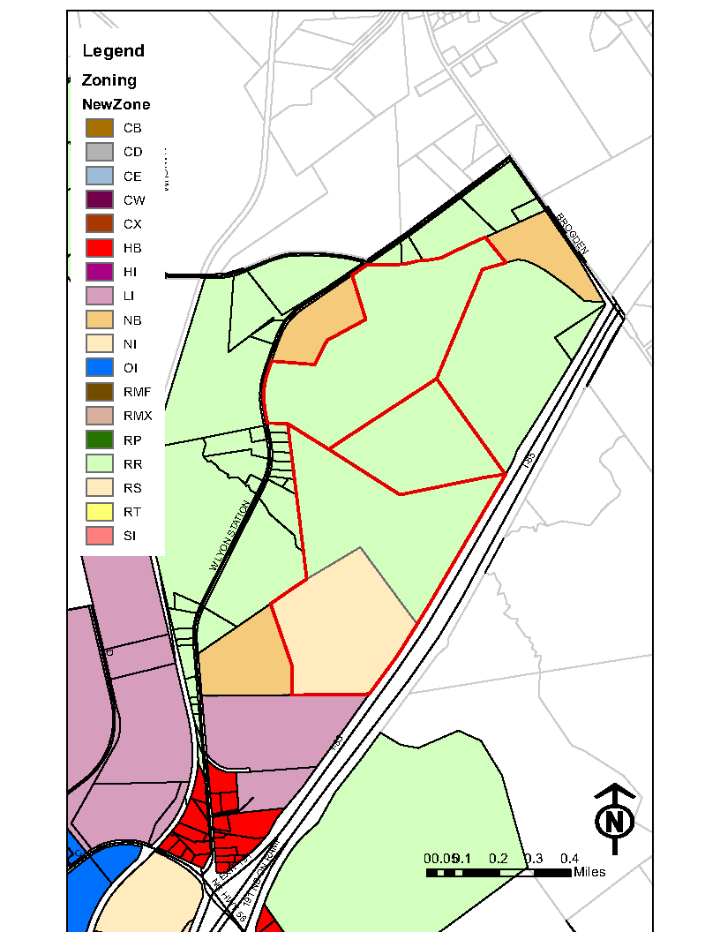
Subject properties outlined in red.

In a PUD the overall density, minimum lot size, and setbacks are determined by the Concept Plan. Single-Family homes are limited to 35 feet in height, and a minimum of 20% of the gross area of the PUD must be dedicated to open space (land that is designated for public or private use, or for the use and enjoyment of owners, occupants, and guests; examples include trails, parks, picnic tables, or natural undisturbed land).

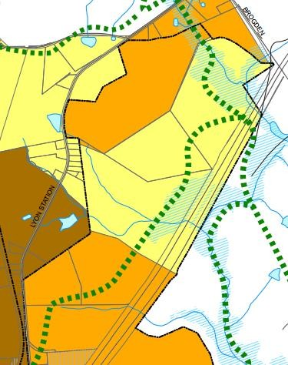
2040 Comprehensive Plan

Design Features
Residential Density | 1-4 Dwelling Units/Acre
Building Height | 1-2 Stories
Front Setback | 35-100 feet
Street Type | Boulevard, Ave, Street, Lane
Block Length | 500 feet - 1,000 feet
Description of category | Lawns and private property make up the bulk of open space. Projects incorporate existing natural features, required stormwater control features into recreation and open space requirements.
Design Features
Residential Density | 50-10 Dwelling Units/Acre
Building Height | 1-3 stories
Street Types | Boulevard, Avenue, Street, and Lane
Block Length | 250-350 feet along major arterials minimum 600 feet between intersections
Description | Central greens, sidewalks, pocket parks. Natural features and stormwater facilities used in formal spaces, in medians along sidewalks.

The proposed density of this project conforms to the 1-4 dwelling units per acre proposed in the Suburban Residential category. The project does not propose a mixture of uses, therefore it does not conform to the TND Mixed Use Category of the Future Land Use Map. However, it does border two properties that are currently zoned Neighborhood Business (NB) that could be used for a future common development plan with this subdivision.

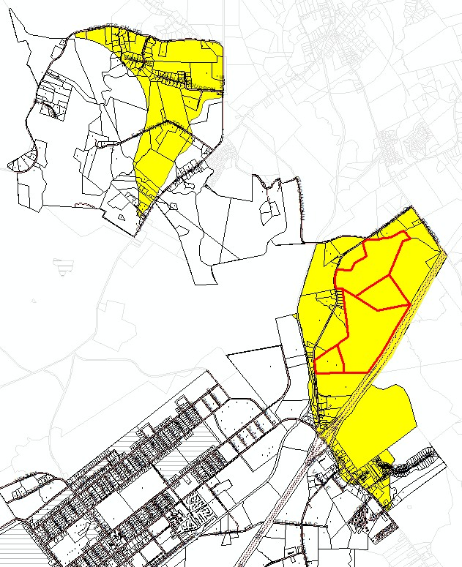
Environmental Considerations
This project is in a Watershed II NSWP Balance of watershed. The densities allowed in this type of watershed are as follows:
- Low Density (not requiring Stormwater Control Measures): 12% Built-Upon-Area
- High Density (requiring Stormwater Control Measures): 30% Built-Upon-Area
There is an option for density up to 70% called a special intensity allocation (SIA). This applies to new development. Only 10% of the entire watershed in our jurisdiction can have an SIA. This would be 97.2 acres of the area highlighted in yellow (972 acres total in this watershed).
This project as proposed will not utilize the Special Intensity Allocation. Instead, the property will be developed with no more than 30% built-upon-area.

Stimmel Associates reviewed the application for preliminary stormwater review and supplied the following comments:
Recommended PUD Conditions
- All roadways to be accepted by the Town of Butner for Ownership and Maintenance shall be designed and constructed in accordance with NCDOT standards.
- Private alleys will not be accepted by the Town of Butner for Ownership and Maintenance.
- All private storm drainage outside of the public right-of-way will be owned and maintained by
the Homeowner’s Association.

Traffic

NCDOT utilizes a system for traffic called Levels of Service. These values range from A (free flowing traffic) to F (stop and go, heavy delays).
Per a capacity analysis performed by Stantec in October 2022 (see attached Traffic Impact Analysis) West Lyon Station Road (which has 5,100 vehicle trips per day) is currently ranked as Service Level B at NC 56, Service Level C at Brogden Road, and Service Level B at Otho Mangum Road.
A traffic impact analysis was performed by Stantec Consulting Services Inc. to determine the possible impacts of this development. The following chart describes the service levels anticipated for this project.

Level of Service | 2022 Existing |  | 2027 No Build |  | 2027 Build |  | 2027 Build with Improvements
 | AM | PM | AM | PM | AM | PM | AM | PM
Lyon Station Road at Brogden Road | C | C | C | D | C | E | C | E
Lyon Station Road at Otho Mangum Road | B | B | B | B | B | B | B | B
Lyon Station Road at Site Access A | N/A | N/A | N/A | N/A | B | C | B | C
Lyon Station Road at Site Access B | N/A | N/A | N/A | N/A | C | E | C | C
Lyon Station Road at Site Access C | N/A | N/A | N/A | N/A | E | F | E | F
Lyon Station Road at NC 56 | C | B | B | B | C | B | C | B
NC 56 at I-85 SB  Ramps | C | B | B | B | C | C | C | C
NC 56 at I-85 NB  Ramps | B | C | B | D | B | E | B | D

At the NC 56 and I-85 Northbound ramp the traffic is projected to increase from C in the evening to D with improvements.
At access C the traffic is projected to be either E or F.
At Lyon Station Road and Brogden Road the traffic is projected to increase from C to E. NCDOT recommended the following:

W Lyon Station Road and Access A
  - Install dedicated southbound left turn lane on West Lyon Station Road with 50 feet of storage and appropriate deceleration/tapers
  - Install dedicated northbound right turn lane on West Lyon Station Road with 100 feet of storage and appropriate deceleration/tapers
  - Site Access A shall consist of one ingress lane and one egress lane with 100 feet of IPS

W Lyon Station Road and Access B
  - Install dedicated southbound left turn on West Lyon Station Road with 50 feet of storage and appropriate deceleration/tapers
  - Install dedicated northbound right turn lane on West Lyon Station Road with 200 feet of storage and appropriate deceleration/tapers
  - Site Access B shall consist of one ingress and one egress lane with 100 feet of IPS

W Lyon Station Rd and Brogden Rd
  - Install dedicated northbound right turn lane on West Lyon Station Road with 100 feet of storage and appropriate deceleration/tapers

NC-56 at I-85 (northbound ramp)
  - Install a dedicated westbound right turn on NC 56 with 300 feet of storage and appropriate taper
  - Extend the existing right turn lane on the I-85 off-ramp to 450 feet of storage and appropriate deceleration/tapers

These requirements will need to be met at the time of preliminary plat in order for the project to obtain NCDOT approval.

Access A
A non-perennial stream exists along where Access A is proposed to be installed. Initially Meritage proposed that the entrance would be along the western property boundary to minimize the impact on the stream (see below).
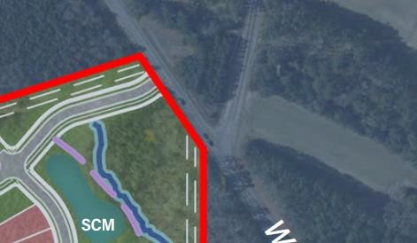
Access A
Existing Cemetery
Otho Mangum Road
non-perennial stream

Town Staff and DOT had concerns about the intersection of Access A and Otho Mangum Road.
- The current angle of Otho Mangum Road would make it difficult to view vehicles coming out of the proposed development.
- Traffic buildup would occur between Access A and Otho Mangum Road with very little separation between the intersections.
Staff and NCDOT requested that Meritage investigate options to improve this intersection and find a way to align Access A with Otho Mangum Road. Reconstructing Otho Mangum Road would be difficult due to an existing cemetery located on the property adjacent to it. Below is the current proposal from the applicant:
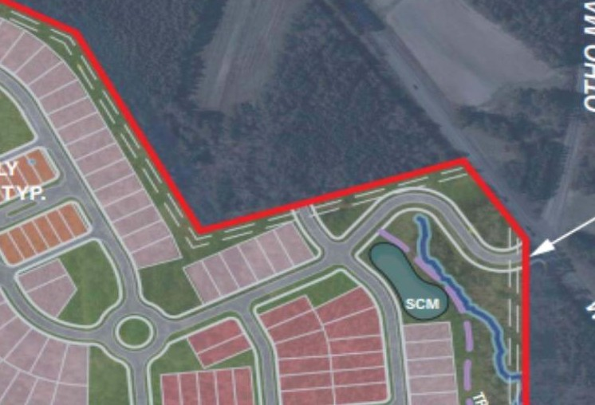

In this example the streets are better aligned, and the impact to the nonperennial stream remains minimal. The curve radii from this proposal does not meet NCDOT standards.
Article 14.3.8 of the Town of Butner LDO States:
“14.3.8 Public street design criteria. Public streets shall be constructed in accordance with the standards contained in the NCDOT Roadway Design Manual or the NCDOT Subdivision Roads Minimum Construction Standards as appropriate.”
This proposal is not in conformance with the LDO.

Article 3.2.6(G) allows for a minor deviation to a concept plan be approved at a staff level without requiring a new rezoning case:

“3.2.6(G) Minor deviation. The Ordinance Administrator is authorized to review and approve a minor deviation to a concept plan or approved conditions if the proposed revision meets all of the following limitations:
  - It does not involve a change in uses permitted or the density of overall development permitted;
  - It complies with underlying zoning standards and other applicable conditions of the approval; and
  - It involves technical considerations which could not be reasonably anticipated during the approval process, or any other change which has no material effect on the character of the approved development or any if its approved conditions.
For example, minor deviations shall include, but not be limited to, the following if they comply with the provisions in (G)(1), (G)(1), and (G)(1) in this subsection:
    - Driveway relocations;
    - Structure floor plan revisions;
    - Facility design modifications for amenities and other site features;
    - Minor adjustments to road configuration or internal circulation;
    - Minor adjustments to building location;
    - Minor adjustments to landscaping;
    - Minor adjustments to lot configuration; and
    - Minor adjustments to utility alignment.”

Redesign of this intersection could occur during the preliminary plat process and staff could approve a change that would conform to Article 14.3.8 without the need for the applicant to reapply for a PUD rezoning.

Utilities

SGWASA and Town Staff have reviewed and provided comments regarding proposed utility requirements for this project. This proposed subdivision will be constructed in phases. 205 homes would be allowed to be constructed as part of phase I of the project and may be supported by current infrastructure.
Sanitary Sewer System

First Phase of the Project: Approximately 205 homes will be connected to the existing 8” gravity sewer main at/near SMH 1710 located in E. D Street, Butner, NC.

Second Phase of the Project: When Phase One of the Project meets the conditions outlined above, the Developer agrees to design, permit, furnish and install the necessary improvements to the Food Lion Lift Station prior to the completed occupancy permit of the first unit of the additional 422 proposed Unit connections.
Third Phase of the Project: When the Project exceeds 422 connections, the Developer will connect to
SGWASA’s “Northern Interceptor” system.
Water System

Potable water can be served for the full 799 residential units by extending from its current terminus, the existing 12” water main along West Lyon Station Road. The Developer will design and construct watermain extensions to the Project, and within the Project.

Proposed Conditions of Approval

The Ordinance Administrator has had discussions with Meritage regarding requested conditions for the Concept Plan. These conditions have changed since the submittal of the narrative (see attachment).
Below are staff recommended conditions for the project:

There shall be no more than eight hundred and thirty-eight (838) residential units on the site and the maximum density shall be no greater than 2.51 dwelling units per acre.

The applicant is currently proposing 789 units for this subdivision. They wish to allow for additional capacity (up to 838 lots) at the time of site plan review as final engineering can either show a need to increase or decrease lot count depending on a variety of factors.

The Town of Butner Land Development Ordinance allows for a minor deviation of an approved conditional zoning per article 3.2.3(F):

“(F) Changes to an approved conditional zoning. The owners of individual parcels may apply for a minor deviation or an amendment so long as the change would not result in other properties failing to meet the terms of the conditions. Any approved changes shall only be applicable to those properties whose owners petitioned for the change.
  - Minor deviation. The Ordinance Administrator is authorized to review and approve a minor deviation to a concept plan or approved conditions if the proposed revision meets all of the following limitations:
    - It does not involve a change in uses permitted or the density of overall development permitted;
    - It complies with the intent of both the underlying zoning standards and other applicable conditions of the approval; and
    - It involves technical considerations which could not be reasonably anticipated during the approval process, or any other change which has no material effect on the character of the approved development or any if its approved conditions.
For example, minor deviations shall include, but not be limited to, the following if they comply with the provisions in (G)(1), (G)(2), and (G)(3) in this subsection:
      - Driveway relocations;
      - Structure floor plan revisions;
      - Facility design modifications for amenities and other site features;

      - Adjustments to road configuration or internal circulation;
      - Adjustments to building location;
      - Minor adjustments to landscaping;
      - Adjustments to lot configuration; and
      - Adjustments to utility alignment and/or stormwater facilities.”

Per this definition a requested change for density would not meet the standards for a minor deviation and would require a resubmittal of proposed concept plan.

The development shall provide dedicated right-of-way along property boundaries to parcels 088701164467, 088701187300, 088803215345, and 088804515138 for possible future roadway connections. Street improvements shall be constructed to the greatest extent practicable to accommodate a 3:1 slope, if required, to the existing grade at property boundaries.

Having stub roads to the end of the property line is a requirement of new subdivisions per article
14.3.5 of the Butner Land Development Ordinance:

“14.3.5 Access to adjoining property. Where, in the opinion of the approving body, it is desirable to provide for street access to adjoining property, proposed streets shall be extended to the boundary of such property.”

Lots 44 feet in width or less, as measured from the front yard setback line, shall provide vehicular access from a rear alley.

Staff originally requested the project have rear loaded alleys. Meritage requested that only a portion of their project have rear loaded alleys. This project proposes three different lot sizes:
- 50ft x 120ft = 317 lots
- 45 x 135ft = 320 lots
- 35ft x 100ft = 152 lots

20% of the lots proposed meet the proposed condition and are located along the main boulevards within the subdivision.

Lots shall be oriented so that the front property line is adjacent to a publicly dedicated right-of- way.

This condition is in conformance with article 14.2.7 of the Town of Butner LDO
“14.2.7 Access requirements. All lots must have public street access and frontage meeting the requirements set forth in Article 6, Zoning, “

Pursuant to Section 14.1.17 of the Town’s Land Development Ordinance: a property owner’s association shall be established to fulfill the requirements of the North Carolina Planned Community Act codified as G.S. 47F-0–101 et seq. and to accept conveyance and maintenance of all common elements (common areas) within the development and said property owners’ association shall be in legal existence prior to the conveyance, lease-option, or other long-term transfer of control of any unit or lot in the development.

This condition is in conformance with article 14.1.17 of the Town of Butner LDO which states the following:

“14.1.7 Property owners’ associations.
(A) Creation. An owners’ association shall be established to fulfill requirements of the state’s Condominium Act, being G.S. §§ 47C-1-101 et seq., state’s Planned Community Act, being G.S. 47F-1- 101 et seq., or to accept conveyance and maintenance of all common elements (common areas) within a development. The owners’ association shall be in legal existence prior to the conveyance, lease-option, or other long-term transfer of control of any unit or lot in the development.”

A declaration, as defined in G.G. 47F-1-103(10) for the planned community shall be recorded prior to the conveyance of any lot in the development and shall contain provisions substantially similar to the following, which provisions shall not be modified or otherwise amended without modification of the CD-PUD approval. Architectural elevations will be required at time of initial zoning permit submittal to ensure compliance with the following standards:
- No residential unit shall have the same architectural building elevation as a single-family detached dwelling unit located on either side or directly across the street from a residential unit.
- For residential units with a width of 38 feet and greater, garages shall be set back a minimum of 5 feet from the front plane of the house which may be defined as a front porch or other architectural feature. For residential units with a width between 28 feet and 38 feet, garages shall be set back a minimum of 2 feet from the front plane of the house, which may be defined as a front porch or other architectural feature.
- Building facades facing public streets shall provide architectural enhancements such as windows, shutters, or other architectural enhancements as shown in PUD documents.
- All front entrances of residential units shall be raised a minimum of 12 inches above finished grade as measured along the front plane of the façade to the livable area of the home. Garage finished floor elevation, side foundations, and rear foundations may be flush with adjacent finished grade.
- Residential units shall be clad with a minimum of 24 inch high masonry material along the base of the front façade and shall wrap and extend a minimum of 2 feet along the side facades.
- Garage doors on single-family detached homes facing publicly dedicated right-of-way shall contain windows, decorative details, and/or carriage style adornments.
- All single-residential units shall have a covered porch with a minimum depth of 6 feet. Porches shall have decorative posts with a minimum of 24 inch masonry at the base.
- Each residential unit shall have a front door with a minimum of 25% glazing, transom, and/or door sidelights.
Discussion between the developer and Town staff has led to an agreement that these aesthetic design considerations will be met for the subdivision. These conditions combat uniformity of elevations proposed in the subdivision and create variety in the structural facades of proposed homes. These conditions will be part of the homeowner’s association declaration. Town staff will review the elevations when an initial zoning permit is submitted. Future home modifications will be reviewed by the homeowner’s association, and depending on the project may also have review by the Town and County Building Department.

Retaining walls over 4 feet tall that are generally parallel to, facing towards, and located within 20 feet of any publicly dedicated right-of-way shall be constructed of high-quality materials including one or a combination of the following: decorative blocks; brick; stone; cast-stone; architectural block; split-faced block; or stucco over concrete masonry blocks. The maximum length of continuous, unbroken and uninterrupted wall plane shall be 100 linear feet. Breaks shall be provided using columns, planted areas, change in material, or another design element not compromising the structural integrity of the wall and deemed appropriate by the Butner Planning Director. This shall not apply to walls associated with culverts or stream crossings or to transportation improvements.

The developer asked to include an exemption to walls associated with culverts or stream crossings or to transportation improvements as it is impossible to determine required heights of retaining walls for these uses without additional engineering.

Detached garages shall only be placed in the established rear yard.
Article 7.4.2of the Town of Butner LDO states the following:

“(E) Location of accessory uses or structures.
(1) No accessory use, structure, or activity, except for permitted fences or walls erected on a property line or an ornamental pond, shall occupy or take place in a required front setback.”
This section of the LDO allows for accessory structures to be located along the side of the home, making the condition requested by the developer more restrictive.

Documents providing for the establishment of a property owners’ association and the declaration for the planned community must be submitted to the Butner Planning Director for review by the Town Attorney before approval and recordation of a record plat. The Town’s review is limited to:
- ensuring that the property owners’ association has clear legal authority to maintain and exercise control over the common area and facilities, including the power to compel contributions from residents and property owners to cover their proportionate share of the costs associated with the maintenance of the common areas and facilities, and
- ensuring that applicable restrictions and conditions herein set forth are appropriately referenced and included within the Declaration.
The Town’s review shall not constitute as approval or endorsement of the documents and shall
not create any rights in any party.

Staff proposed this condition to ensure that homeowners’ association documents will meet the listed conditions.

Utility lines shall be installed underground as allowed by utility providers and code requirements.

Town Staff originally requested that utility boxes located in the front yards be screened from the public view. The applicant updated this condition to indicate utilities were to be buried.

Utility boxes for alley loaded buildings shall be in the alley. The applicant may be exempt from this provision if the utility company provides a statement in writing.

The applicant requested this condition. Town Staff wanted to grant flexibility to the developer if it was determined by the utility companies that this condition would not be able to be met.

Outdoor lighting shall be full cut-off and shielded to prevent glare and light spill over to minimize impact to neighboring residential properties.

This condition is in conformance with article 8.3.4(B) of the Town of Butner LDO:

“8.3.4(B) Direction of illumination.
- In all districts, lighting of nonresidential development shall be directed downward. In addition, upwardly-directed lighting shall not be used to illuminate structures, except for low- wattage architectural lighting.
- Outdoor lighting shall not shine directly into the yard or windows of adjacent residential
uses.”

The development shall provide a 5 foot wide sidewalk on both sides of proposed public streets except where the 40 feet wide Environmentally Sensitive Street Section has been utilized, in which case a wider 6 foot sidewalk on one side of the street shall be provided.

Article 14.4.2 of the Town of Butner LDO states the following:

“ 14.4.2 Sidewalks Required locations.
- Along both sides of new and existing major thoroughfares and minor thoroughfares.
- Along one side of new and existing collector and sub-collector streets, except that upon review by the approving body, both sides may be required where one or more of the following conditions exists:
  - The current or projected average daily traffic volume is greater than 8,000 vehicles per day;
  - The posted speed limit is greater than 35 mph;
  - The street is identified as a pedestrian route on a pedestrian transportation network plan;
  - Other pedestrian safety, access, or circulation needs are identified; and/or
  - Along one side of new and existing local streets, unless other pedestrian safety, access, or circulation needs are identified.
Collector streets are defined in article 17 of the LDO as:

“COLLECTOR STREET. A street whose principal function is to carry traffic between local, subcollector, and cul-de-sac streets and streets of higher classification, but which may provide direct access to abutting properties.”
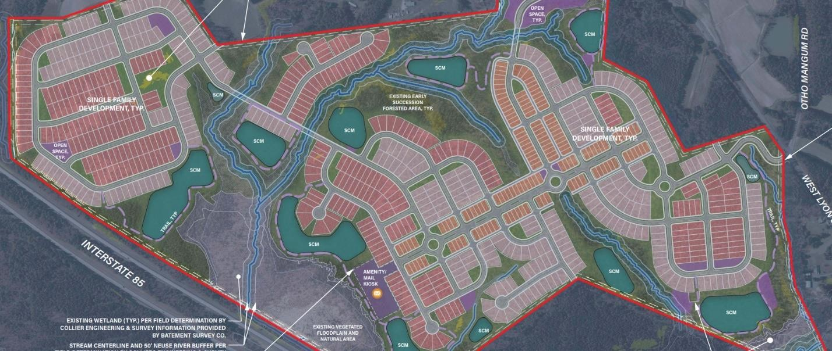

The Environmentally Sensitive Street discussed in this condition carries traffic between other local streets and cul-de-sac streets so it falls under the definition of a collector street. This condition complies with the Town of Butner Land Development Ordinance.

To ensure planting diversity, no species of proposed street trees shall constitute more than 25% of required plantings.

Article 9.4.11 of the Town of Butner Land Development Ordinance states the following:

“9.4.11 In order to encourage the use of a diverse mixture of plant material, the number of trees or shrubs from a single genus may not exceed one-third of the total number of trees or shrubs required to be planted by this article on a particular property.”

This condition proposed by the developer is more restrictive than the ordinance requirements but does comply with the LDO.

All roadways to be accepted by the Town of Butner for Ownership and Maintenance shall be designed and constructed in accordance with NCDOT standards.

See “Access A” section on page 6 of this report.p

Private alleys will not be accepted by the Town of Butner for Ownership and Maintenance.

Private alleys are not built to NCDOT standards. It will be the responsibility of the homeowners’
association to maintain them.

All private storm drainage outside of the public right-of-way shall be owned and maintained by the
Homeowner’s Association.
This condition was proposed by Stimmel Engineering after review of application.

ZONING MAP REASONABLENESS REVIEW:

When adopting or rejecting any petition for a zoning map amendment, a statement analyzing the reasonableness of the proposed rezoning shall be approved by the governing board. This statement of reasonableness may consider, among other factors:
- Whether, and to the extent which, the proposed amendment is consistent with the comprehensive plan, Land Use Plan, and any other relevant plans;
- Whether, and to the extent which, the proposed amendment addresses a demonstrated community need;
- Whether, and to the extent which, the proposed amendment is compatible with existing and proposed uses surrounding the land subject to the amendment
- Whether, and to the extent which, the proposed amendment would result in a logical and orderly pattern of development;
- Whether, and to the extent which, the proposed amendment would encourage premature development in the area subject to the amendment;
- Whether, and to the extent which, the proposed amendment would result in adverse impacts to property values in the area surrounding the land subject to the amendment; and
- Whether, and to the extent which, the proposed amendment would result in significantly adverse impacts on the natural environment.
ORDINANCE ADMINISTRATOR RECOMMENDATION:
Staff recommends approval of the rezoning subject to the conditions described above.
It is at the discretion of the Town Council whether to accept, change, add, or deny any conditions proposed for this development.

ATTACHEMENTS

- Narrative
- Zoning Map
- Concept Plan (11x17 2 sided)
- Traffic Impact Analysis
- Consistency Statement

