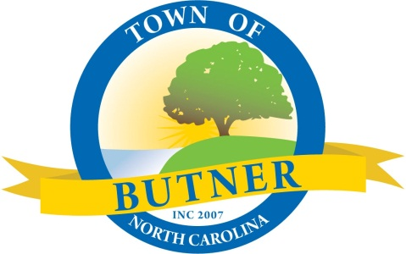

2024
BUTNER TOWN COUNCIL
REGULAR MEETING DATES
COUNCIL MEETING ROOM, BUTNER TOWN HALL
415 CENTRAL AVENUE
7:00 PM

January 4 | July 11*
February 1 | August 1
March 7 | September 5
April 4 | October 3
May 2 | November 7
June 6 | December 5

Regular meeting schedule is the first Thursday of each month
*Date changed due to 4th of July holiday

Please contact Town Clerk, Barb Rote for questions: 919-575-3109 or brote@butnernc.org.

